# Chapter 1: Differing Perspectives on Quality

***Chapter Outline***

* Differing Perspectives on Quality
  + - What is Quality?
    - Recognizing both Product and Service Dimensions of Quality
    - Differing Functional Perspectives on Quality
    - Three Spheres of Quality
    - Other Perspectives on Quality
    - Arriving at a Common Understanding of Quality Using a Contingency Perspective of Quality

## Overview

The entire concept of quality is what one of my professors once called an “arm-waiver.” We all intuitively know what it means, yet when we are asked to explain it, we just sort of wave our arms.

Chapter 1 defines the terms. The author references various definitions of quality. He makes the distinction between *service* and *manufacturing* from a quality perspective and delves into “The Supply Chain.” Consideration of quality as it applies to the modern supply chain expands our understanding of its application. Professor Foster has taken the concept of the supply chain and made it integral to the subject of quality. Any book on quality must discuss Deming. The author makes reference to Deming throughout the book.

The focal point of the chapter is the question “What is Quality?” Professor Foster supplies a list of topics product and service quality that can be ideally used in a class discussion:

* Performance
* Features
* Reliability
* Conformance
* Durability
* Tangibles
* Service reliability
* Responsiveness
* Assurance
* Empathy
* Availability
* Professionalism
* Timeliness

The author looks at quality from different perspectives. This list is also an excellent starting point for class discussion:

* Supply chain
* Engineering
* Operations
* Strategic management
* Marketing
* Financial
* Human resources



**Figure 1-1** A Global Supply Chain Model *Source:* Foster, S. Thomas; Sampson, Scott E.; Wallin, Cynthia; Webb, Scott W, Managing Supply Chain And Operations: An Integrative Approach, 1st Ed., © 2016, p.15. Reprinted and Electronically reproduced by permission of Pearson Education, Inc., New York, NY.

Chapter 1 will ideally fit into a standard 100-minute class period.

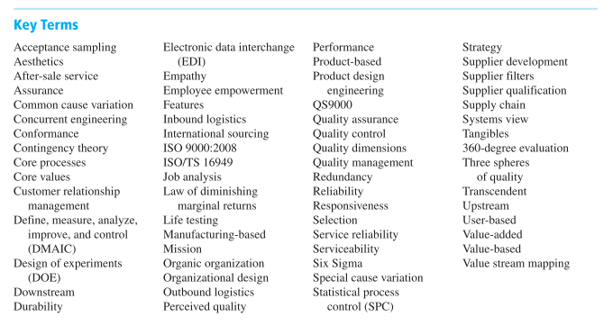

***Discussion Questions***

**1. Why is *quality* a difficult term to define? How can we improve our understanding of quality?**

This is an ideal question to open the discussion of the topic of quality. Ask the class to define *quality* and record their comments. You will typically find a myriad of answers, but there should be a common theme among them.

**2. Briefly discuss Garvin’s eight dimensions of quality. Is Garvin’s multidimensional approach a step forward in improving our understanding of quality? Why or why not?**

Garvin lists the following:

* Performance
* Features
* Reliability
* Conformance
* Durability
* Serviceability
* Aesthetics
* Perceived quality

Using Garvin’s terminology, these terms identify five different aspects of quality. One might say, “Quality is in the eye of the consumer.”

**3. Is there a difference between service quality and product quality? If so, what are the implications of these differences for a manager of a service business, such as a restaurant or a retail store?**

Service quality suggests an achievement in a level of customer service and is more subjective than the definition of product quality that is related to a tangible product. Service quality is more difficult to define because of its numerous customer variations, and it is therefore more difficult to achieve quality success based on this wide latitude of customer opinion. You can demonstrate this in class buy surveying, for example, the service quality of a major brand (e.g., AT&T, Verizon, etc.) and then surveying the opinions of the class regarding one or more service quality dimensions.

**4. Define the concept of empathy.**

On page 6, the concept of empathy is discussed: *Finally, consumers of services desire* ***empathy*** *from the service provider. In other words, the customer desires caring, individualized attention from the service firm.*

The author’s discussion of empathy uses the relationship between a waiter and customer. You might extend this conversation by asking for other examples. Does empathy enter into a manufacturing situation? Dilbert’s Pointy-Haired-Manager is an excellent tool for this discussion.

5. Why is communication within an organization an important part of the quality improvement process?

On page 6, the author says: *It is difficult to devise a coherent strategic plan relating to quality when communication is imprecise.*

Think about the people involved. Do the marketer, engineer, order processor, and manager all speak the “same language?” Communication enables planning. In a multidimensional environment, communication becomes more difficult simply due to different backgrounds. How do you make this happen? What are the priorities that must be shared?

6. Compare and contrast the engineering perspective and marketing perspective of quality? How could an overemphasis on the engineering perspective work to the disadvantage of a business organization?

The textbook (page 13) says: *The marketer focuses on the perceived quality of products and services as opposed to the engineering based conformance definition of quality. The question then asks whether the engineering approach could be self-defeating.*

This is pretty much a follow-up to question 5. Do the communications styles and backgrounds influence the marketer and the engineer? What are the goals of the engineer? What are the goals of the marketer? Do they coincide or conflict? What should the goals be in an efficiently run organization?

7. Describe the “systems view” that underlies modern quality management thinking. Which of the perspectives of quality discussed in Chapter 1 is most closely aligned with the systems view?

Some discussion questions might be:

1. What is the systems view?
2. What do the approaches have in common?
3. How are the approaches different?
4. How do the different approaches affect the ultimate consumer?

This diagram depicts the basic approach to planning.

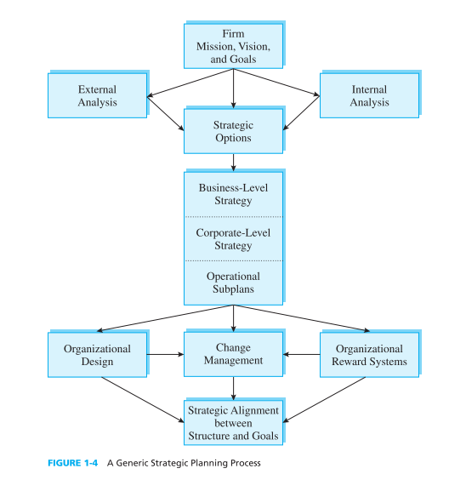

8. Why is planning an important part of the quality process? How could a firm’s quality management initiatives be adversely affected if planning was not a part of the process?

Refer back to the question on communication (question 5). You might review Garvin’s list:

* Performance
* Features
* Reliability
* Conformance
* Durability
* Serviceability
* Aesthetics
* Perceived quality

Which of these are the most dependent upon planning? Are any of them unaffected by planning? Does poor planning adversely affect any of these items more than others?

**9. Research has shown that quality is still a major concern of the majority of CEOs in American corporations. Is this level of concern about quality warranted? Please explain your answer.**

A discussion about the competition between American and foreign products would be productive. How has the automotive industry been affected by the apparent quality or lack of quality of foreign cars? Have other industries been affected in this manner? Has the movement of our nation from manufacturing to service been affected by quality, either actual or perceived?

**10. What is meant by the phrase *cost of quality*? How can this phrase help a firm address its quality concerns?**

The article *Quality Strategy at GE* contains the following statement: *GE denied that such problems forced GE to adopt its new quality program. “We are not in trouble,” they said, citing the robust profits. But they conceded that “the time wasted, the money wasted, in field fixes, in quality problems, in working things out, across corporate America, across the world, is enormous.”*

Does this give you any insight into the attitudes at GE after Welch’s departure? What other aspects that have been discussed apply here? Look at the American automobile industry again. Is the comparison that is being made between GE and the American automobile industry valid? How does long-range planning affect quality in cases like these?

11. What are the major differences between traditional human resource management and total quality human resource management? How does total quality human resource management transcend traditional human resource management in regard to providing an environment that is supportive of quality concerns?

The table below lays out the question succinctly. This table should be an excellent springboard for in-class discussion.

HRM versus TQHRM

***Traditional HRM TQHRM***

Process characteristics Unilateral role Consulting role

Centralization Decentralization

Pull Release

Administrative Developmental

Content characteristics Nomothetic Pluralistic

Compartmentalized Holistic

Worker-oriented System-oriented

Performance measures Satisfaction measures

Job-based Person-base

SOURCE: Adapted from R. Cardy and G. H. Dobbins, “Human Resources Management in a Total Quality

Environment,” *Journal of Quality Management* 1, 1 (1996):3.

**12. Describe the three spheres of quality. How do these spheres provide another way to place the field of quality in perspective?**



Notice the three quality descriptors:

* Management
* Assurance
* Control

How do they differ? How are they the same? Notice that the Venn diagram above shows overlap. What are the implications of the overlapped areas? Where does quality management end and where does quality assurance begin? How does quality control fit into the picture?

13. Discuss the value-added perspective on quality. What are the implications of this perspective for the manager of a business organization?

A value-added activity can be pinpointed by asking, “Would this activity matter to the customer?” In other words, in most cases, a value-added activity will have economic value to the customer.

Looking back at the GE example that is discussed in question 10:

* How does value added enter into the discussion?
* Look at our consumer goods: does the concept of value added influence your purchasing decisions?
* Can you actually identify a value-added component?
* Is value added more obvious by it presence or absence?

More generally, how is quality a value-added item? Getting back to the automobile industry, how did the influx of Japanese cars in the 1960s reflect on the concept of quality adding value to a product?

14. How does contingency theory inform decision making when implementing improvement efforts?

Page 19 states: ***Contingency theory*** *presupposes that there is no theory or method for operating a business that can be applied in all instances*

A company that defines part of its mission as "valuing and satisfying our customers through personalized service" likely will pursue a different technological approach toward its customers than a company with the mission of "applying technology to solve customer problems."

The contingency approach to quality also helps settle the different perceptions concerning the definition of quality, for example:

* Do you as a consumer feel that quality is not as important in a lower priced item?
* When a product has been on the market for an extended period of time, do you still observe quality?
* Do you have different expectations of quality for a high priced item than you do for an inexpensive item? Why?
* Do you have the same expectation of quality on similarly priced items based upon their use or application, for example, food vs. clothing?

15. Should a firm consider the law of diminishing marginal returns when striving to improve quality? Why or why not?

On page 14, the statement is made that there is a point where the continued quest for quality becomes uneconomical. Figure 1-6 illustrates this concept. Is there a subtle problem here? How might the quality of one product affect the perception of overall product quality? How does the cost of quality affect other products when the cost of quality on another product has proven uneconomical? In that situation, what choices exist? Can you think of any examples?

16. Are the perspectives of quality independent of one another? If not, describe ways in which they are interrelated.

This chapter is named *Differing Perspectives on Quality*. Does the author make the point? List the perspectives and identify the differences and similarities. Are there any trends or common points? On what are these perspectives based? Given the preceding questions, what conclusions can you make?

17. How can an understanding of the multiple dimensions of quality lead to improved product and service designs?

As identified earlier, Garvin identified eight dimensions of quality:

* Performance
* Features
* Reliability
* Conformance
* Durability
* Serviceability
* Aesthetics
* Perceived quality

Do they apply differently to products or services? How does each of these dimensions directly apply to a product or a service?

**18. What is your concept of quality? Is it multidimensional, or does it focus on a single dimension such as features, reliability, or conformance? Explain your answer**.

Do you react differently as a consumer or a supplier? Can you use these attitudes in business? As we have discussed, marketing and manufacturing approach quality from different perspectives. What are the common points? How does management deal with the differences or the similarities?

19. Describe an instance in which you and a coworker (or superior) perceived the needs of a customer very differently. How did your differences in perception influence how each of you wanted to meet your customer’s needs?

What aspects of quality made the most difference to you or your co-worker? Does your superior view quality in the same manner as you do? Why? In the class environment, do your needs and expectations differ from that of your instructors? Does the question of quality differ for you and your instructors?

***Case Study 1-1: FedEx: Managing Quality Day and Night***

This cast study provides insight into the unique problems faced by a service-based company. Central to this discussion are three questions that the company asks its employees:

1. What do you need from me?
2. What do you do with what I give you?
3. Are there any gaps between what I give you and what I need?

This case also introduces the topic of Quality Improvement Process (QIP). This might be a good time to set the tone of future lectures. This case study might be an excellent one to use early in the semester.

***Case Questions:***

**1. What is FedEx’s “common language” of quality? Is it important for a company to establish a “common language” of quality? If so, why?**

How does Fedex’s three-pronged “People-Service-Profit” reflect quality?How does Fedex’s twelve component “Service Quality Indicator” reduce communications difficulties.

**2. There are several different perspectives of quality, including the operations perspective, the strategic perspective, the marketing perspective, the financial perspective, the HR perspective, and the systems perspective. Which of these perspectives are being emphasized by FedEx? Why?**

Does the “common language” allow personnel to cross boundaries? Does inclusion of management in the teams affect the concept of quality? The SQI is a cross-functional tool. How does this affect the situation? The case states that the SQI *“ensures the involvement of frontline employees, support personnel, and managers from all parts of the corporation when needed.”* Do the employee incentives assist this as well?

**3. Is FedEx’s level of emphasis on quality appropriate? Why or why not?**

Who is FedEx’s competition? Is quality a focal point in this industry? How does the customer measure quality? What specific attributes do the customers use to judge quality?

***Case Study 1-2: Granite Rock Company: Achieving Quality through Employees***

This case presents quality through the management perspective. A strategy for using this case might be to ask the students to list the specific steps taken by Management to address the quality issue. The case also discusses the individual employees IPDP, the Individual Personal Development Plan. It might be interesting to contrast this approach with both Managing by Objectives (MBO) and Managing by Exception (MBE). These are two methods of management that have gained a major foothold in industry and could yield a good discussion.

***Case Questions:***

**1. Rather than focusing on human resource management (HRM) as a means of supporting its quality initiatives, Granite Rock could have chosen another area as its focal point (i.e., marketing, operations, information systems, and so on). How does a focus on HRM support a company’s quality initiatives?**

This statement might be the key: *The managers at Granite Rock knew that a resulting decline in customer satisfaction was inevitable and responded to this self-assessment by deciding it needed to become more customer focused*. …*As explained by CEO Bruce Woolpert, you can’t have employees out telling customers “yes” unless everyone else in the company knows how to follow up on “yes.”*

How does the focus on individual employee growth fit within the guidelines of HRM?

**2. Discuss the different components of Granite Rock’s HRM initiatives. How can each of these components support the company’s quality efforts?**

The list of initiatives might include:

* Employee training
* Individual Personal Training Plan (IDPD)
* Atmosphere of trust between management and rank-and-file
* Winning the Malcolm Baldrige National Quality Award

While on the surface these might seem to be independent items, how are they related in actuality? What is the effect of these items on the individual employee?

3. Discuss CEO Woolpert’s feelings about communication with the customers (paragraph 2). What happens when others in the company don’t know what has been promised to the customer? How can quality management help to overcome this situation?

The key sentence in this paragraph is: *As explained by CEO Bruce Woolpert, you can’t have employees out telling customers “yes” unless everyone else in the company knows how to follow up on “yes.”*

While there had been discussion of the impact that management has upon quality, if the employees do not feel empowered, quality will suffer. Do the actions that are directly aimed at the employees affect quality? This communication is perhaps the core of the topic.

## Websites of Interest

<http://www.nist.gov/baldrige/> -- The home site for the Baldridge National Quality Program

<http://www.asq.org/learn-about-quality/quality-tools.html> -- American Society for Quality

<http://www.thecqi.org/> -- Chartered Quality Institute

<http://www.managementhelp.org/plan_dec/mbo/mbo.htm> -- A detailed look at Management by Objectives

<http://www.ge.com/en/company/companyinfo/quality/whatis.htm> -- An overview of Six Sigma from GE’s perspective